BOEUF RIVER BRIDGE
LADOTD Structure No.05420260907001
Recall No. 026240

Description of the Bridge
The Boeuf River Bridge (Structure No.05420260907001, Recall No. 026240) on LA 15 approximately one mile west of Alto in Richland Parish, Louisiana is a steel Parker through-truss bridge originally constructed in 1938-39.

National Register of Historic Places Eligibility
The Boeuf River Bridge is eligible under Criterion C: Engineering as an example embodying the distinctive characteristics of a steel Parker through truss bridge in Louisiana.

Status of the Bridge
The bridge is owned by the Louisiana Department of Transportation and Development (LADOTD). Through consultation with the Federal Highway Administration, the Louisiana State Historic Preservation Officer, the Advisory Council on Historic Preservation this bridge is scheduled to be replaced under State Project H.000974 and Federal Project No H000974. The estimated replacement date is 2020.

As a mitigation stipulation for the Adverse Effect to this historic bridge, the steel truss portion is being marketed to another entity for historic preservation. If ownership of the steel truss is not transferred to another entity for moving to another location for an alternate use, the steel truss will be demolished along with the other portions of the bridge.

Re-use of the steel truss as a bridge is encouraged. If you are interested in acquiring this bridge for adaptive, non-vehicular use please read the stipulations for bridge ownership transfer below. This bridge will be marketed until November 1, 2016. Contact Stacie Palmer at stacie.palmer@la.gov or 225-242-4517 by October 21, 2016 if you are interested in acquiring this bridge for adaptive re-use or if you have questions on submitting a proposal.

Approximate Dimensions of the Steel Truss Portion
The bridge consists of a single 160-foot, Parker truss with an out-to-out deck width of 30.2 feet and a roadway width of 24 feet.
Funds for Relocation and Reuse of the Bridge
Funding that would be used for demolition of historic bridges can be used for its preservation at a new location. The estimated cost of demolition of the Boeuf River Bridge is $500,000.00. The historic truss portion of the bridge contains lead paint. The estimated cost of lead paint abatement is $260,000.00. An amount not exceeding this estimated cost of demolition ($500,000.00) would be made available to the new owner as a reimbursement for relocation and historic preservation of the bridge. This would include lead paint abatement costs which would be considered a preservation activity and reimbursable.
Stipulations for Bridge Ownership Transfer
The entity receiving the bridge must agree to the following:
The entity would be charged the salvage value of the steel truss which is estimated to be $6,000.00 (According to Title 7 Section 14(A) of the Louisiana Constitution, property or things of value of the state shall not be donated to or for any person, association, or corporation, public or private.)
The bridge has lead paint which will require abatement. The entity who acquires the bridge will be responsible for lead paint abatement.

The entity must accept full ownership and all financial and legal responsibilities, including maintenance, liability, and permitting for the steel truss.
The entity shall ensure that the steel truss is closed to motorized vehicular traffic (i.e., cars and trucks).
Relocating and reassembling the steel truss will be the responsibility of the entity taking ownership.
The proposed use of the steel truss will be subject to the approval of FHWA, LADOTD, and SHPO.
The entity will be required to execute a preservation agreement that will include the above stipulations.
Submitting a Proposal

Interested parties must submit a proposal to LADOTD in writing (either by email or letter) of their interest by November 1, 2016. Please reference project number H.000974 in your proposal.
Send proposals:
Via email: Stacie.palmer@la.gov
Via mail:
Louisiana Department of Transportation and Development
Section 28
P.O. Box 94245
Baton Rouge, LA 70804-9245
Attn: Stacie Palmer

The proposal must address:

Location and use: Where will the bridge be relocated, what will be its new use, and how it will be made accessible to the public?

Setting: Will the bridge continue to maintain a similar crossing as its original site, such as a water crossing or as a separation structure? Does the proposed relocation site have a similar setting as the original?

Assumption of responsibilities: The new owner must demonstrate understanding of the specific responsibilities they will take over when ownership is transferred, including title and insurance. The proposal must specifically discuss that the new owner will:

- Maintain the bridge and the features that give the historic bridge its historic significance for a period of at least 20 years; and
- Assume all future legal and financial responsibility for the historic bridge, which may include an agreement to hold the state transportation department harmless in any liability action.

Rehabilitation: Are there plans prepared for the rehabilitation of the structure on site? Do the plans meet the Secretary of the Interior Standard? In the case of disassembly, are disassembly plans prepared?

Requirements and studies: Describe any additional special requirements for the reuse of the bridge (e.g., if the bridge will be used for pedestrians, railing geometry and capacity restrictions for this use should be considered) and any additional studies or environmental clearances that are needed for the relocation, including potential archaeological survey of new site.

Cost estimate of the cost to relocate the structure and the reinstall at new site, including how funds will be obtained or raised.

Schedule: Outline of the proposed relocation schedule, addressing ability to have bridge off its current site by the scheduled replacement date (to be determined by LADOTD) and plans for temporary storage of the bridge, if needed.

Evaluation of Proposals
Proposals will be reviewed by a selected committee including representatives of LADOTD environmental and bridge staff, and the LA State Historic Preservation Office. Each proposal will be reviewed and evaluated based on how well it meets the above proposal criteria.

If the first choice in owner withdraws from the process prior to relocation, the bridge will not be re-marketed. Rather, the review committee's second choice in owner, if any, will be selected. The timeframe for relocation will not be re-started with the re-selection; however, a relocation extension may be granted at the owner's discretion. If there is no proposal that meets the above proposal criteria, then the bridge can be demolished.

Schedule for review of proposals

Proposals will be reviewed within 2 months of submittal deadline.

Additional information:
If you have questions about the bridge or the process of submitting a proposal please contact Stacie Palmer at (225) 242-4517 or Stacie.palmer@la.gov.

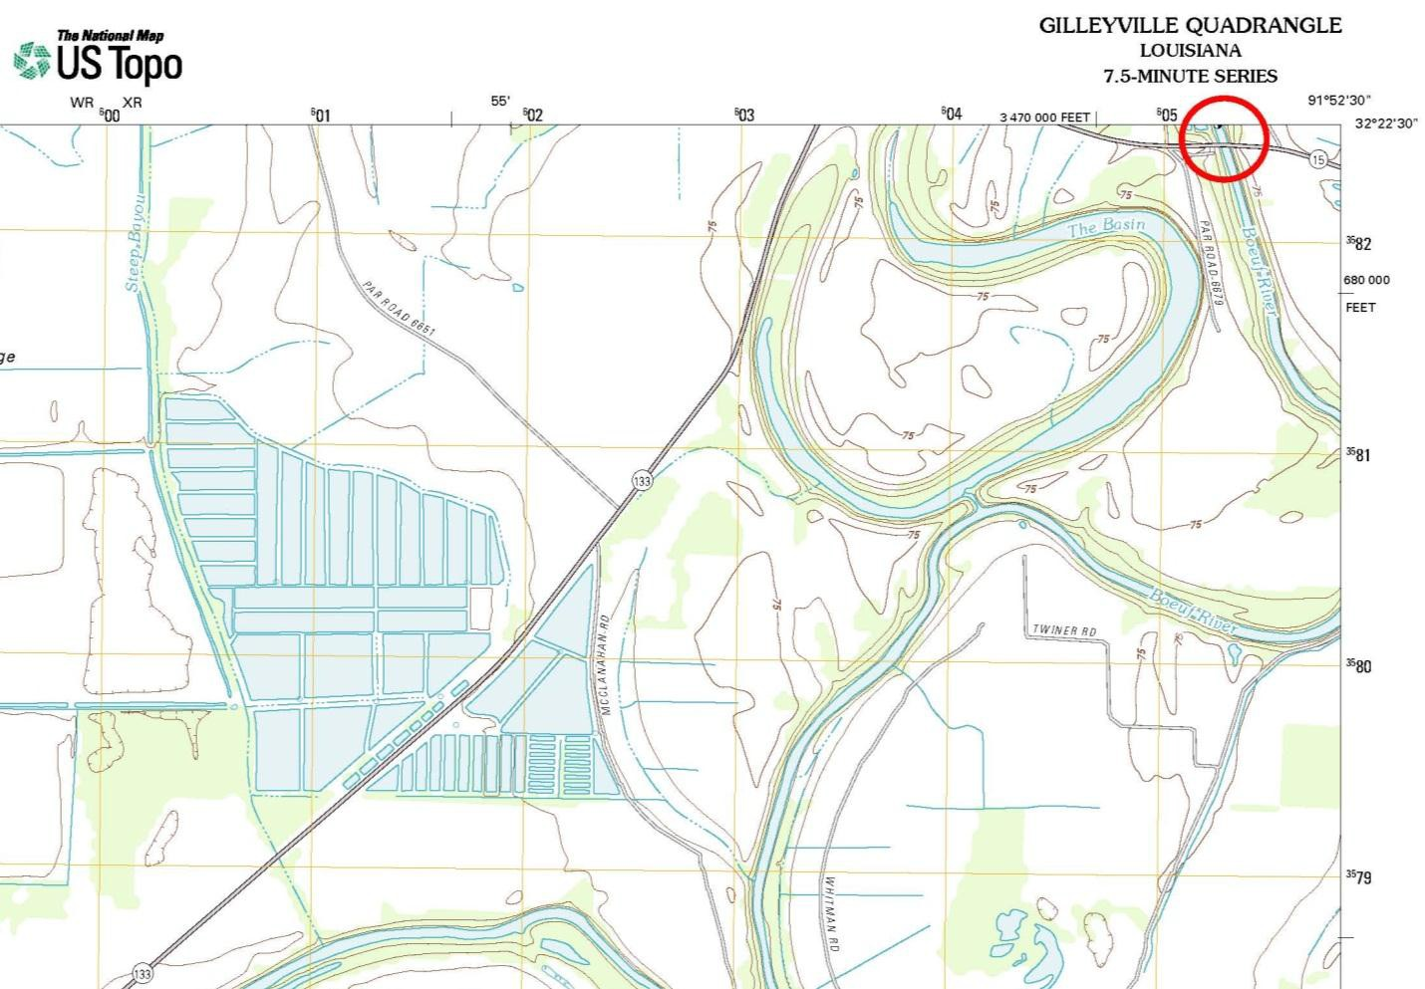
Boeuf River Bridge Location Map: U.S. Department of the Interior, “Gilleyville Quadrangle, Louisiana 7.5-Minute Series.” United States Geological Survey (USGS) 7.5-minute quadrangle, 2012.

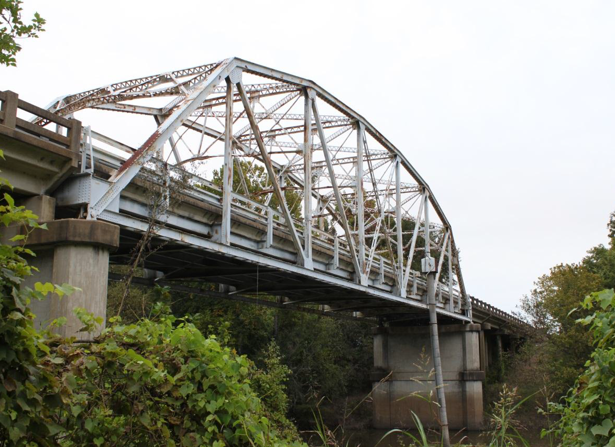
The Boeuf River Bridge. View facing northeast.

